York Pirates! Instruction Manual

Controls

|  |  |
| --- | --- |
| **Key** | **Control** |
| Up Arrow | Enable forward movement |
| Down Arrow | Stop forward movement |
| Left Arrow | Turn left |
| Right Arrow | Turn right |
| F | Interact with islands |
| Esc | Exit menus |
| LMB | Select button |
| O | View map and objectives |

Gameplay

Sailing:

During sailing mode you can use your ship to move between islands. You can also randomly encounter enemy colleges’ ships if you sail around in their territory (the territory you are currently in is displayed at the top of the screen).

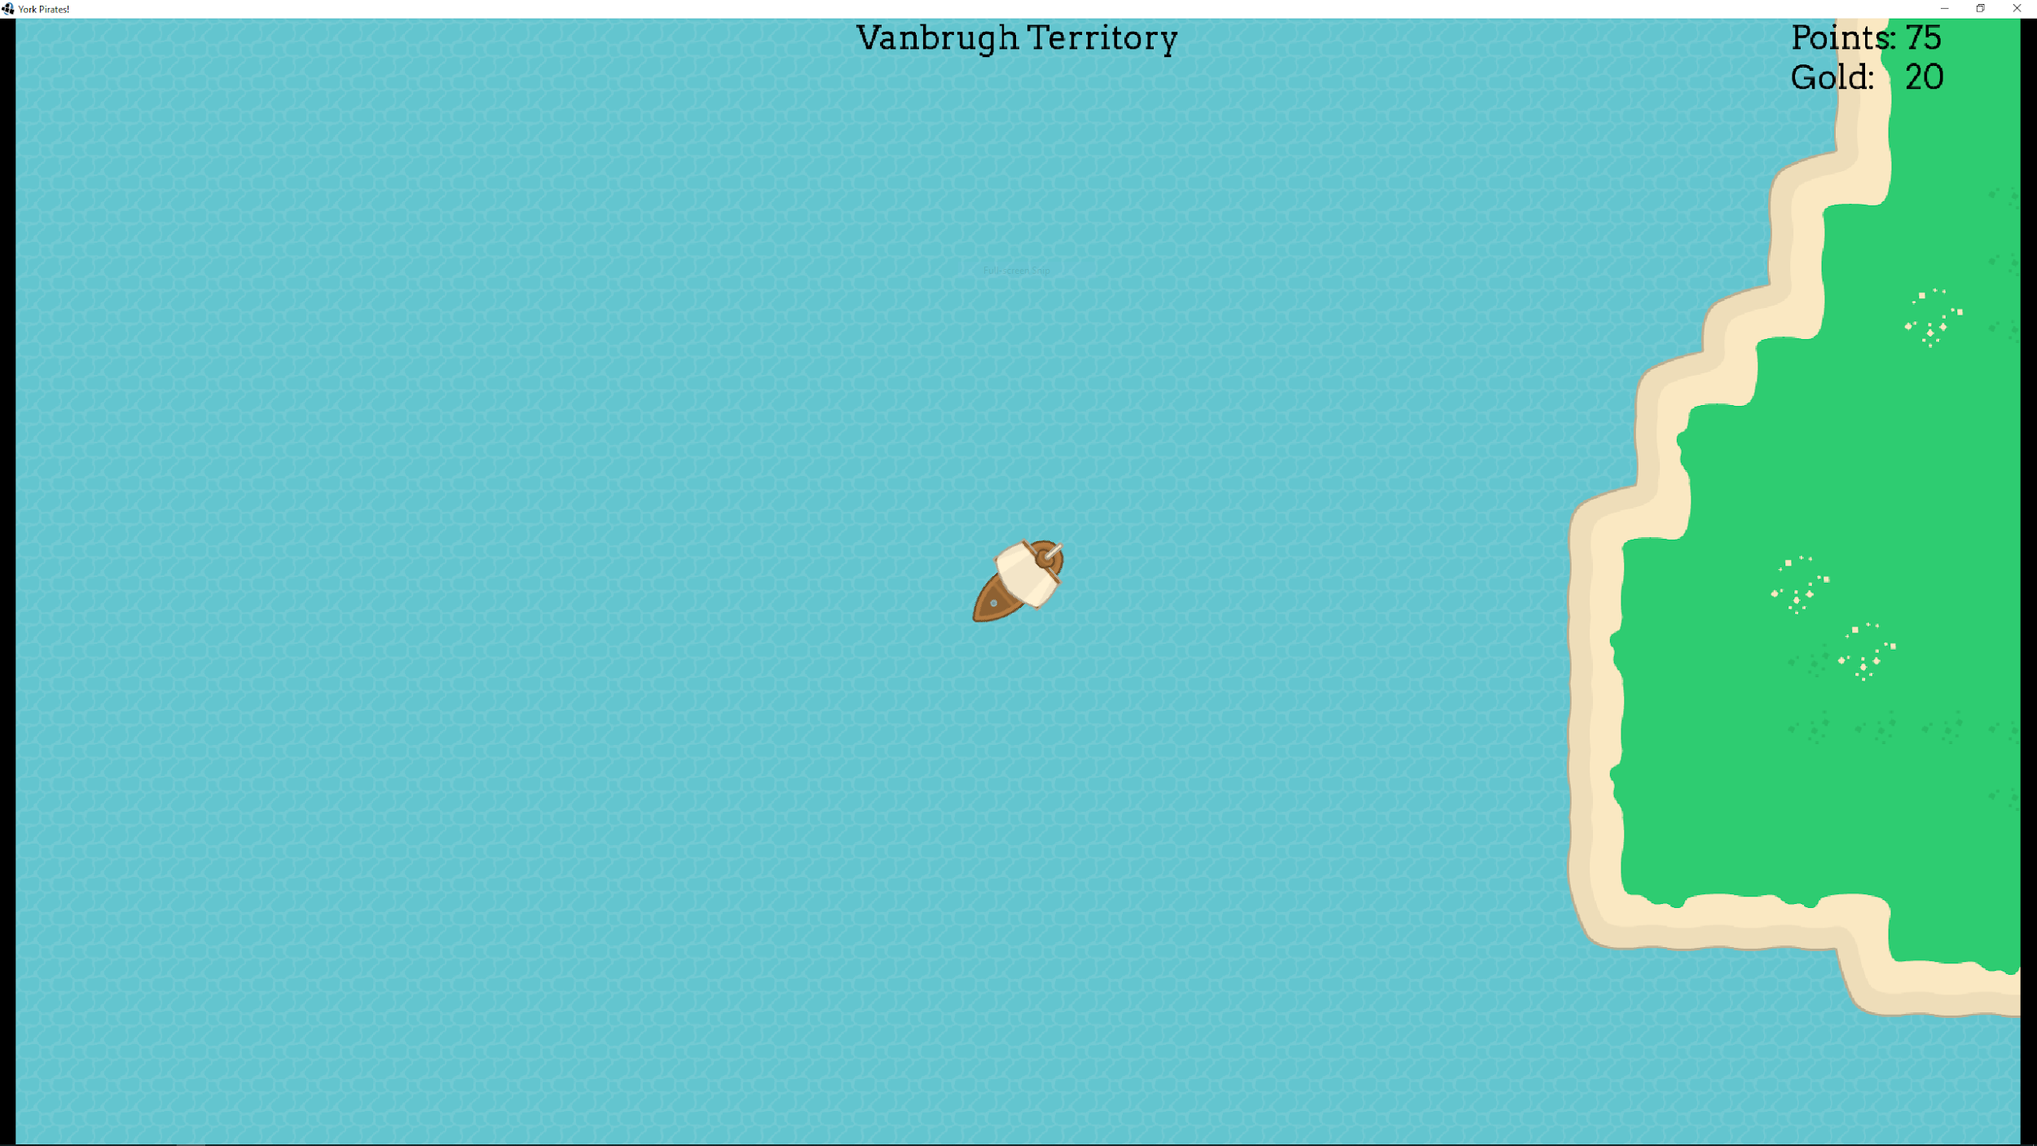

If you sail to a college’s island you can challenge their boss ship. If you successfully defeat a college’s boss you will take over their territory and will no longer encounter hostile ships there. You will also be able to heal at that college’s island (for a cost). Stormy territory is where you will encounter bad weather, which earns you more points but takes health and has chance of encounters with sea monsters.

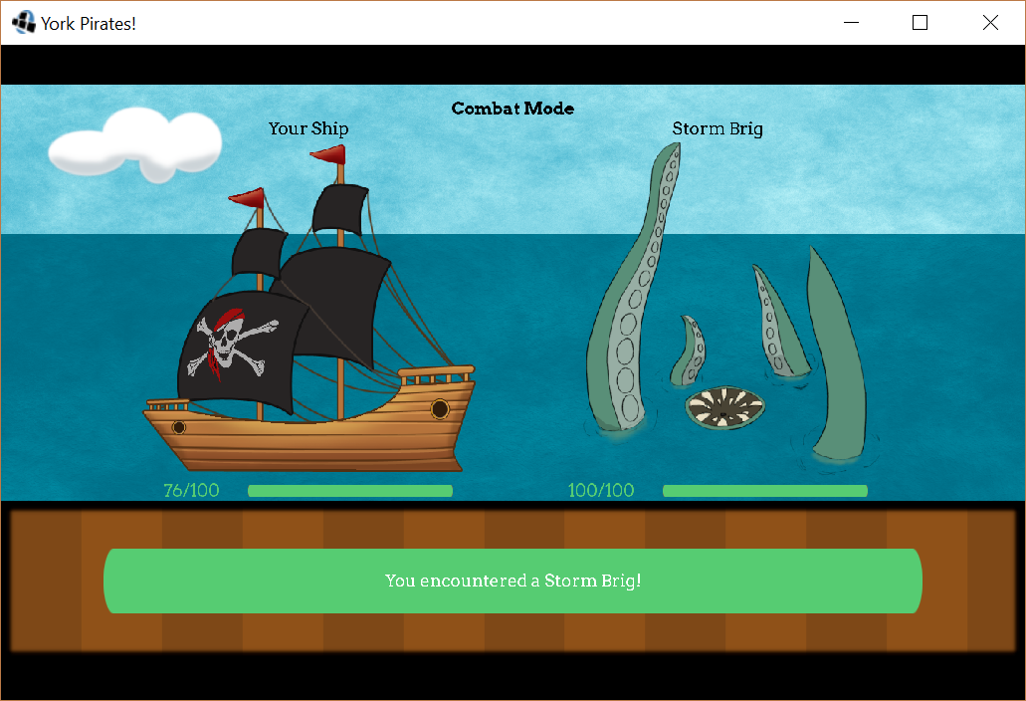

Some islands house departments rather than colleges. These islands are neutral and so can always be used to repair or even apply unique upgrades to your ship.

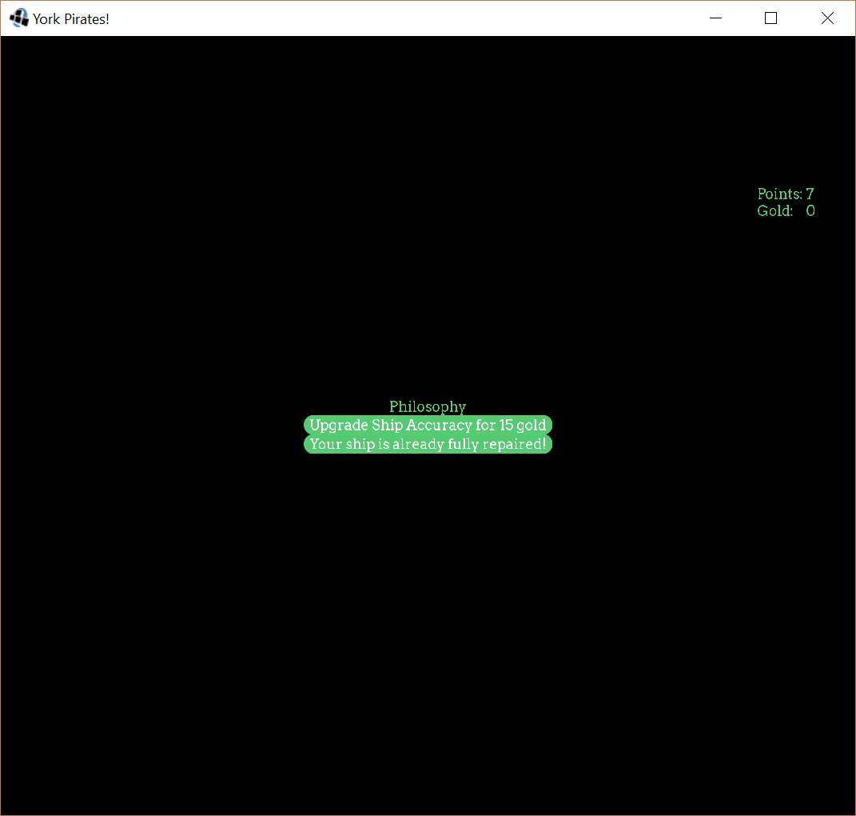

Be careful not to run into the rocks, as you may get stuck or encounter an enemy you are not equipped to fight.

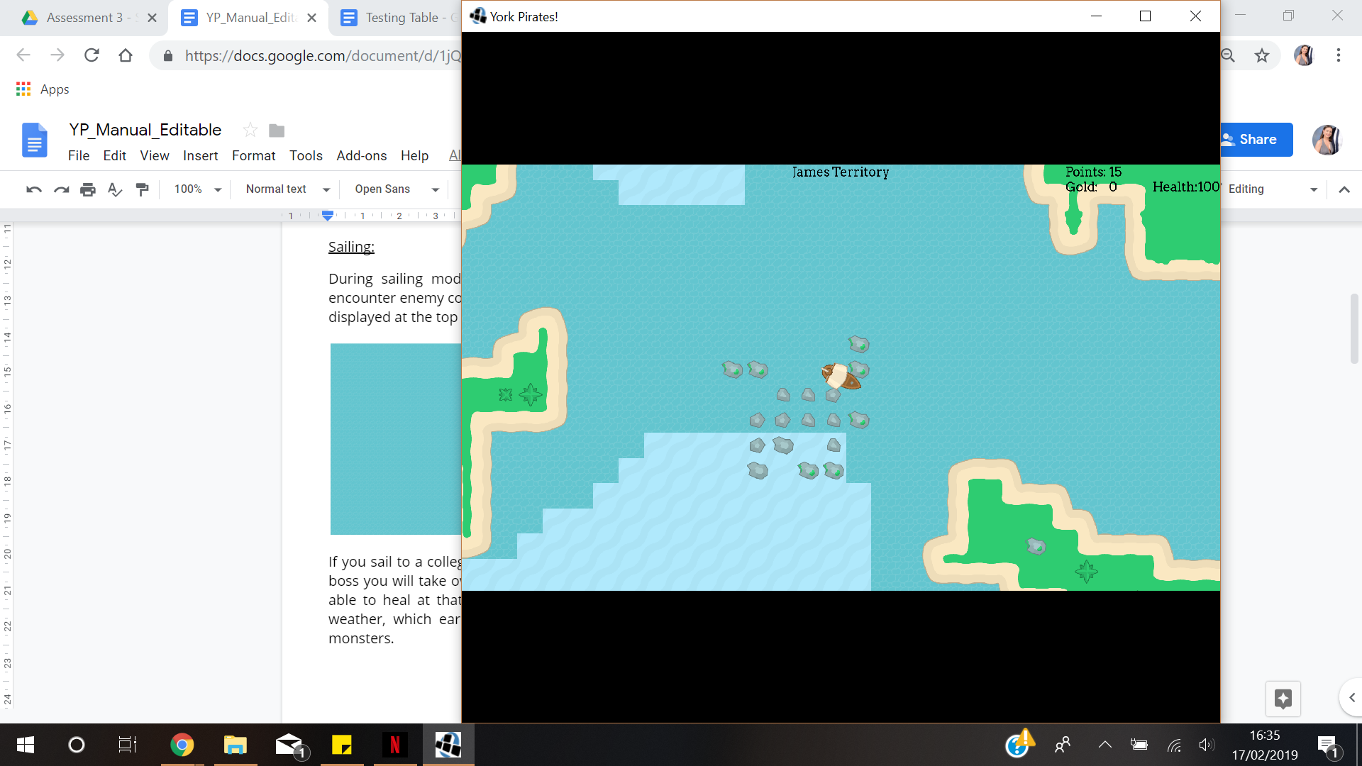

To view the whole map and see objectives, press ‘O’.

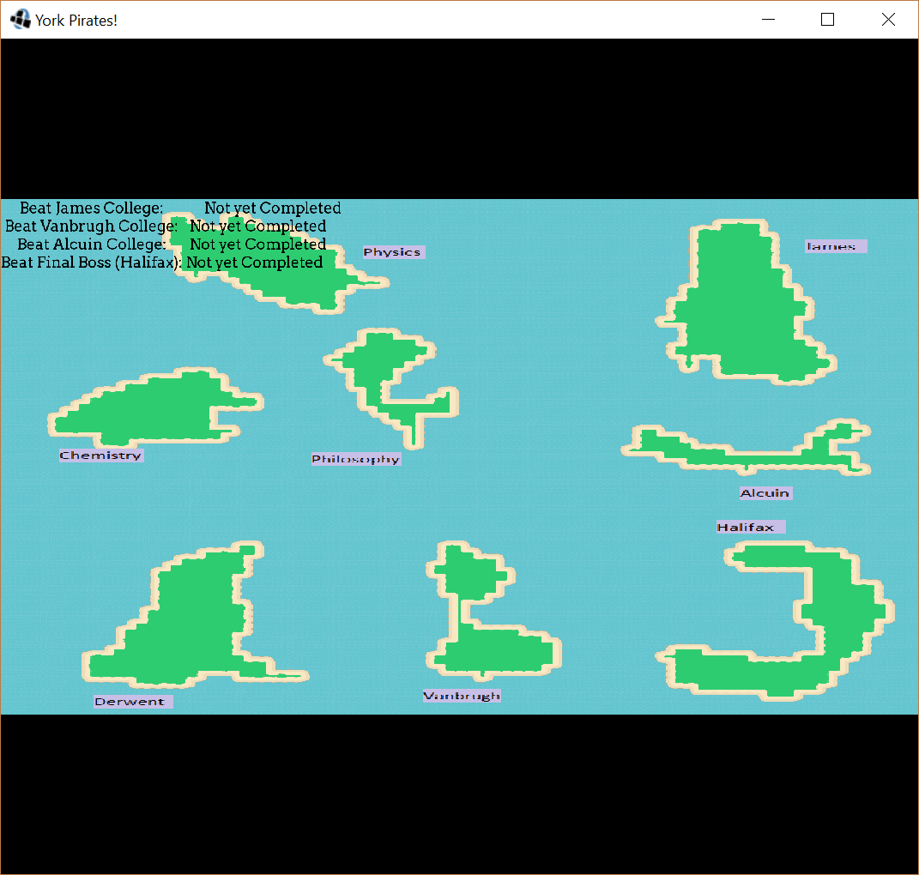

Combat:

During combat mode you are able to select attacks to use against the enemy ship in order to defeat them. You can also flee if you feel you are unable to defeat the enemy. Successfully defeating an enemy ship will reward you with points and gold.

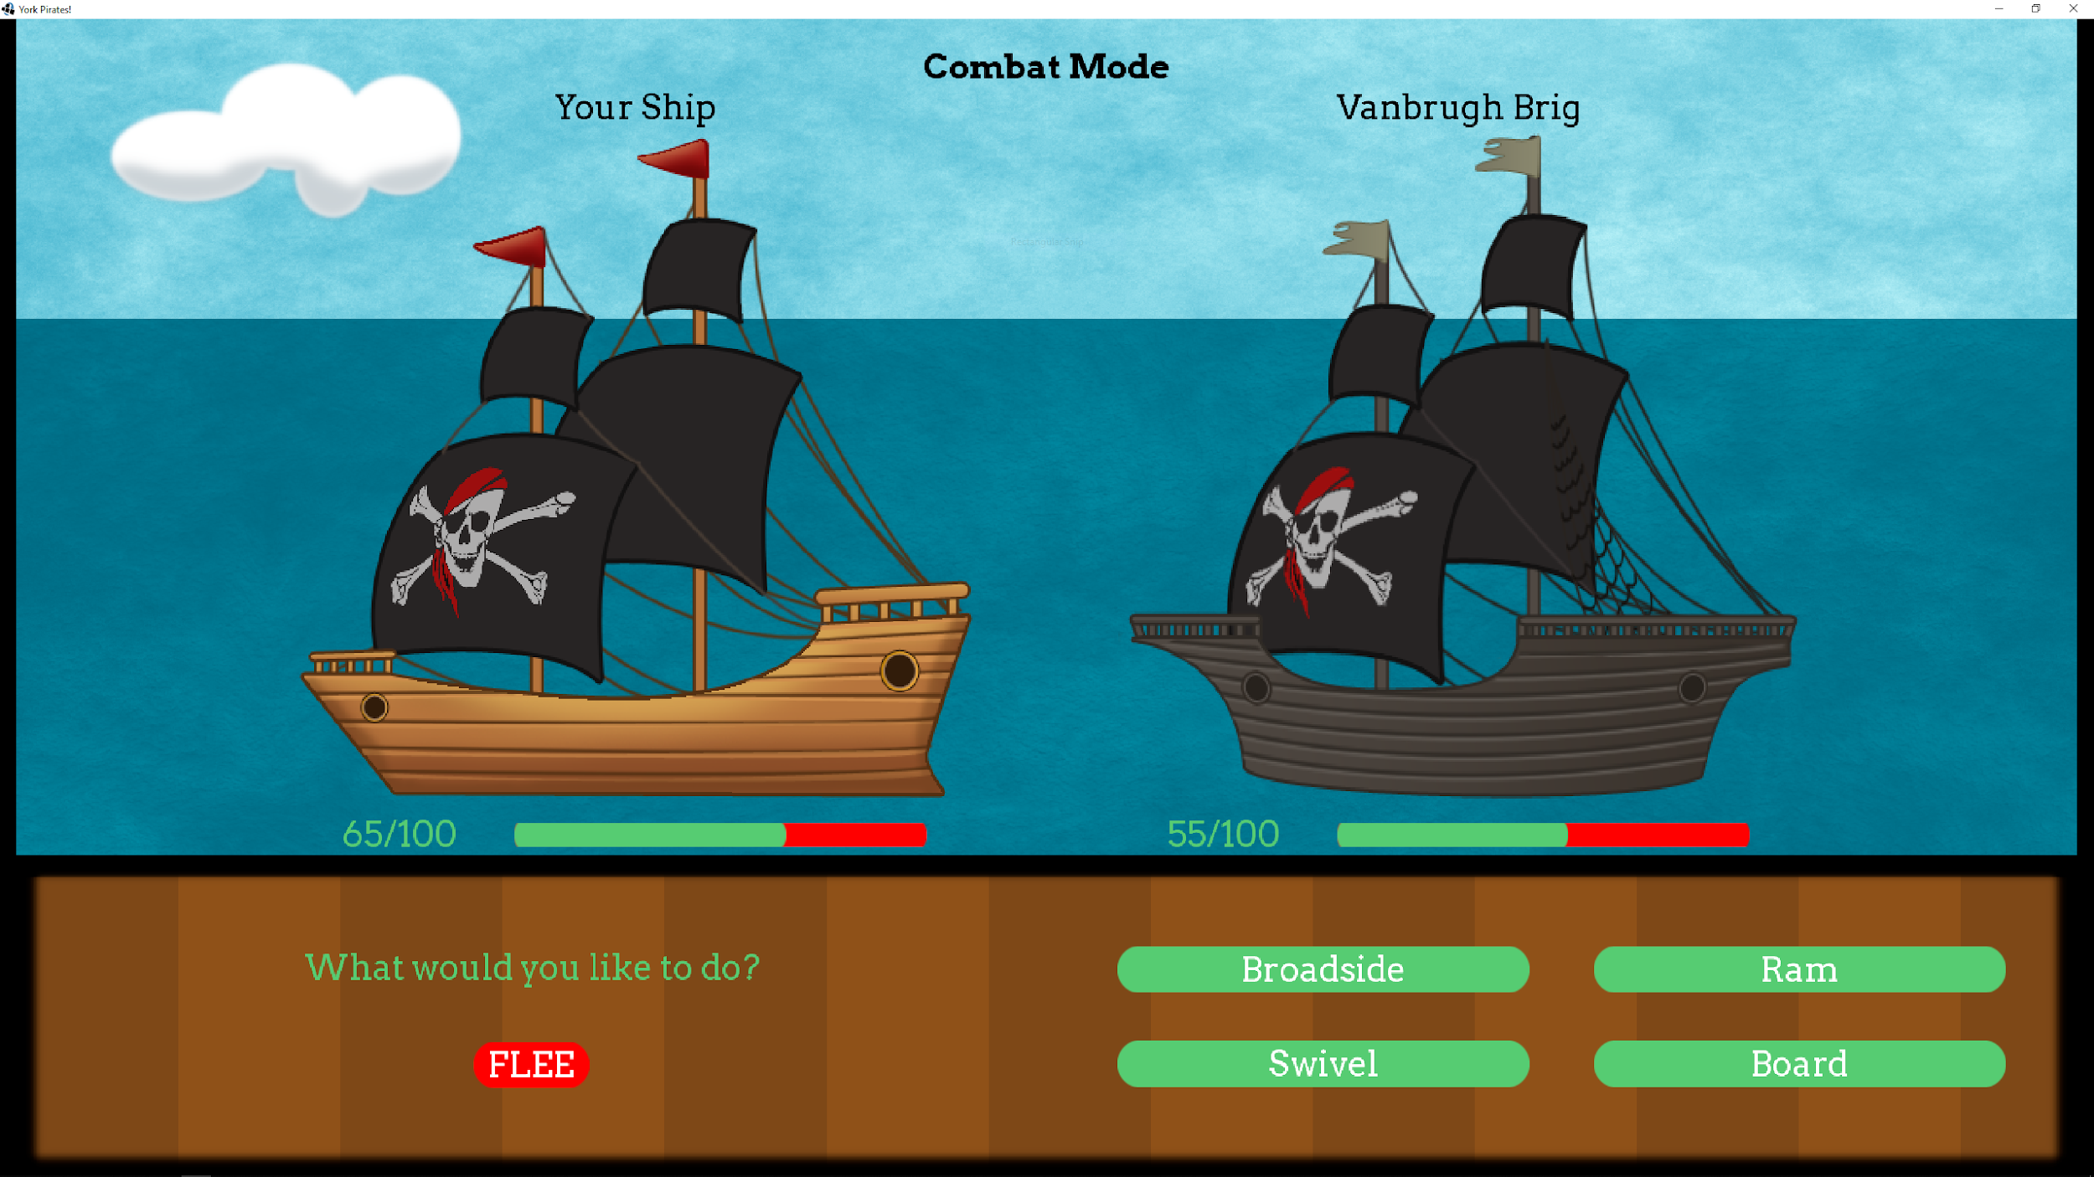

At colleges you will encounter their fort, it is harder to defeat them than regular encounters.

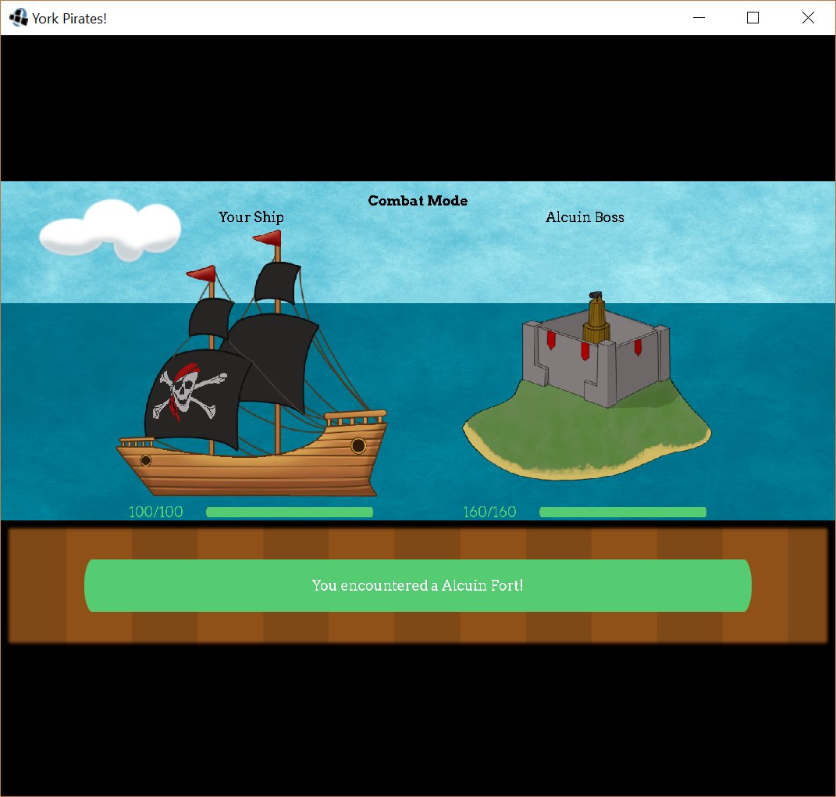

The final boss is located at Halifax and requires upgraded health and accuracy to defeat them.

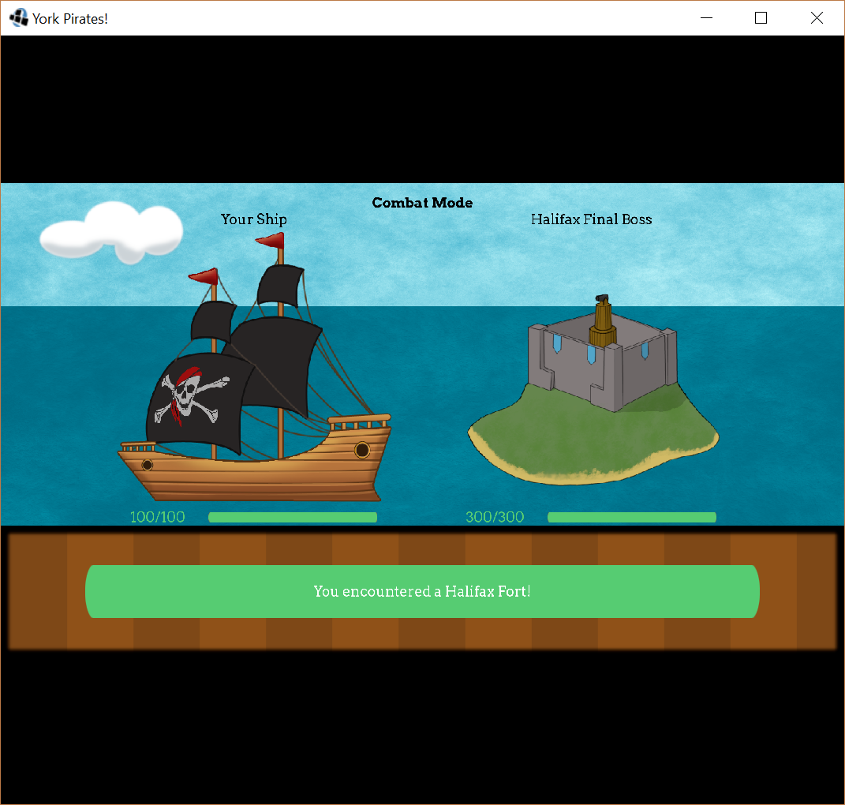

Minigame:

Accessed by interacting with Derwent island. They are already your allies.



2 player game, where the opponent is the computer. Roll 3 dice and compare scores. Below is a hierarchy of scores. If you have a better score than the computer, you win; if the computer has a better score than you, you lose. Else, it is a draw and you go again.

The hierarchy of scores is shown below:

Best Score

4 5 6, worth 15

“Trip” = 3 identical dice, worth 8 + val of single dice

“Point” = 2 identical dice, worth 2 + val of different dice

“Dud” = no pattern on die, worth 2

1 2 3, worth 1

Worst Score

To play, bet your gold.

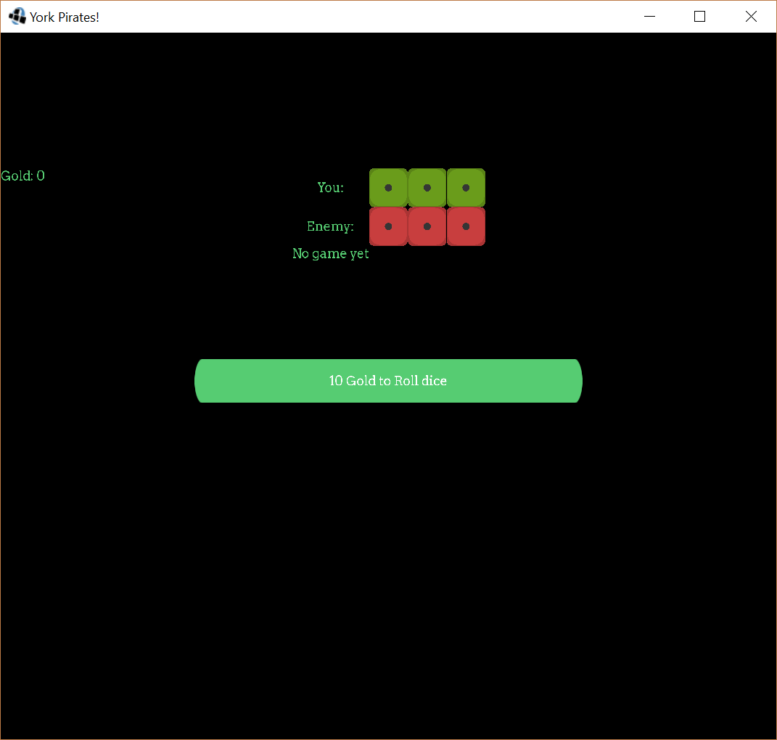

If you do not have enough gold to play, you can sell your soul. But beware, if you lose then the game is over.

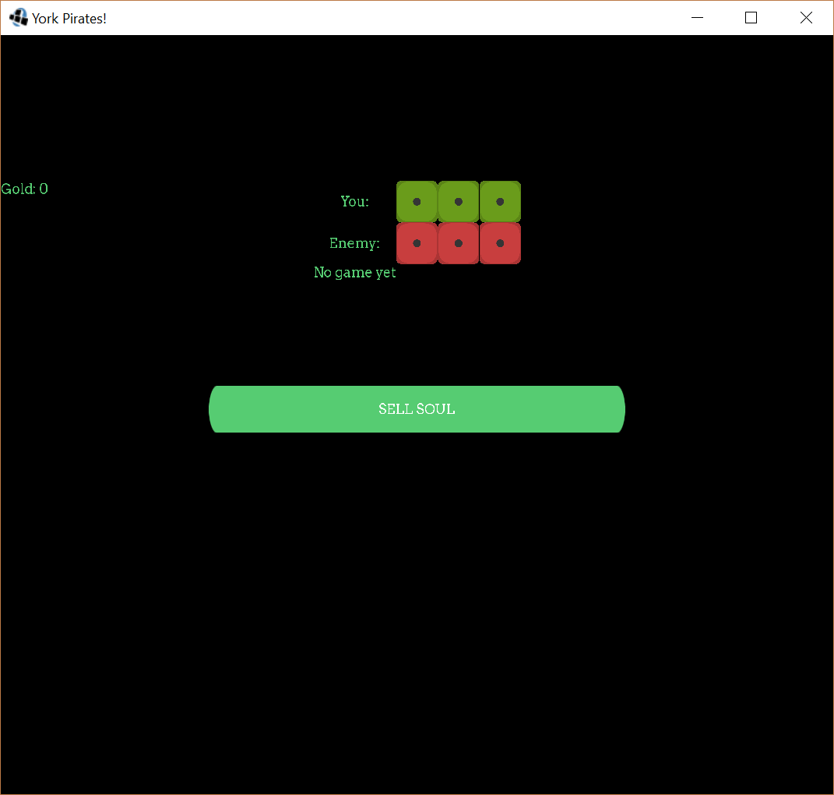

If you win, you are awarded 100 gold.

